Celebrating your Marriage

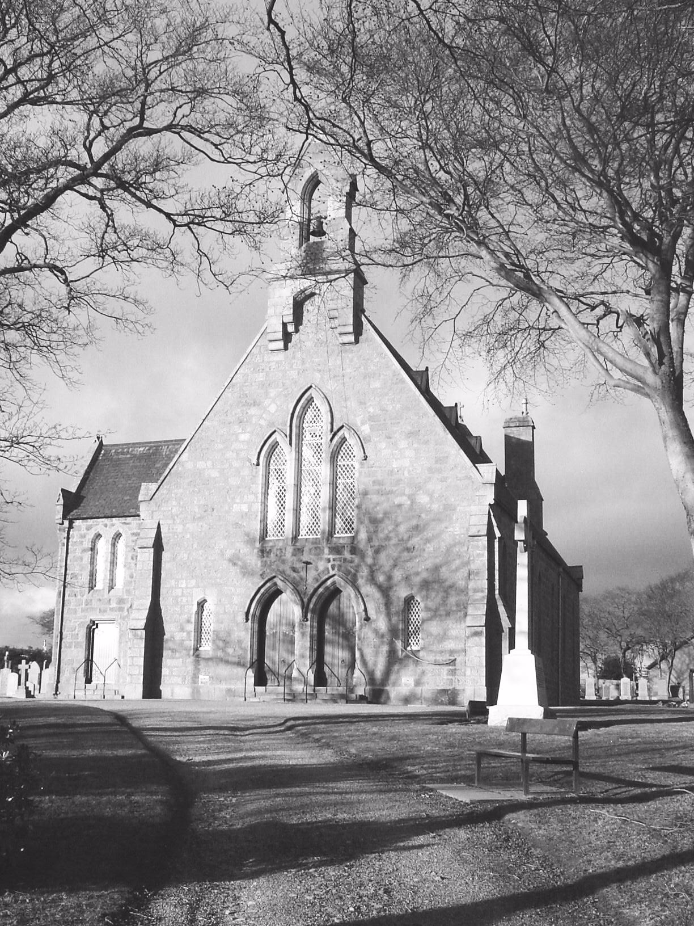

at Belhelvie Parish Church

Congratulations on your decision to get married! We’re delighted for you and look forward to our involvement in your wedding day.

We recognise that there’s a great deal to plan and prepare for in every wedding, and to help you we’ve summarised the things you need to know about the wedding ceremony itself. Please don’t hesitate to call if things are unclear or you have any concerns. We want to ensure you have a memorable and meaningful day. And if your plans change, please remember to keep us in the loop as we plan holidays and other weddings around your dates.

Every Blessing as you make your plans,
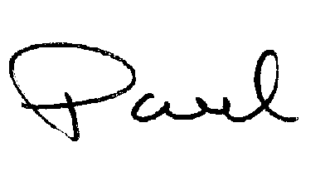
Rev Paul McKeown, Minister, Belhelvie Church

- Where should we get married? Most of the weddings I conduct are held in the church itself, but now that hotels are able to offer a fuller wedding package – including the ceremony – I’m sometimes asked to marry couples in other venues. My own view is that if you want a religious ceremony it should really be held in the church, especially as these days the state registrars are able to officiate at non-religious ceremonies outwith the registry office. Some people feel reluctant to have a church wedding because they don’t attend regularly, or because they feel it has to be a ‘big thing’ when they prefer to have a smaller wedding. From my perspective, neither of those things are a barrier to your having a church wedding, and I’d be happy to discuss the issues with you further.

- Registrar: Part of your legal responsibility is to notify the Registrar of your plans to marry. As of 2007, people marrying at Belhelvie Parish Church are required to register at the Aberdeenshire Registry Office, 29 Bridge Street, Ellon, AB41 9AA (Tel 01358 720295). If you are marrying elsewhere you must see the Registrar for the district in which your wedding ceremony is taking place. You must see the Registrar 4-6 weeks before the date of your marriage, taking along a form M10 (available online at http://www.gro-scotland.gov.uk). Birth certificates of both parties must be presented, and if there has been a previous marriage, appropriate death certificate or divorce papers are needed too. The very latest you can apply for a marriage schedule is two weeks before the wedding, but it is highly inadvisable to wait this long.

- Marriage Schedule: This is the form that the Registrar issues for your marriage, and it must be picked up from the Registrar's Office in person a couple of days before the wedding. The schedule must be produced prior to the date of the wedding. (It is a good idea to bring it to the wedding rehearsal where it can be given to the minister for safekeeping). It is important to realise that if no schedule is produced on the day, the minister cannot legally marry you.
  - The people required to sign are the bride, the groom, the best man, the chief bridesmaid and the minister. All must be over 16.
  - It is a good idea to choose someone to take the schedule back to the Registrar's Office, which has to be returned within 3 days of your marriage.

- Marriage Fees: Current charges for Church Weddings at Belhelvie Parish Church are:
  - For Non-members - £320
  - For Members - £ 220
  - These figures include heating/lighting, cleaning, services of church officer (beadle), organist’s fee and surcharge for non members for hire of building.
  - For weddings outwith the church, it is appropriate to make a donation to the church in recognition of minister’s time and travelling expenses. A figure of £200 is suggested.
  - Fees are payable at least two weeks before the ceremony. A cheque for the full amount should be made payable to Belhelvie Parish Church and sent to the minister – Rev Paul McKeown, The Manse, Balmedie, Aberdeenshire AB238YR

- Order of Service: The minister is responsible for the conduct of your wedding service and you should liaise with him well in advance before having the Order of Service printed. An organist will be provided by us for church services, and at the end of this booklet there is a list of suitable music for entrance and retiral, as well as the signing of the register. A CD of this music can be made available for you to borrow should you need it. In addition we can suggest a wide range of hymns and songs to choose from for your service. If you want musical items not on this list, please speak to the minister. We will require you to source any sheet music not on the prescribed list. For services outside the church, the couple must make their own musical arrangements.

- Rehearsal: A rehearsal is normally held a few days before the wedding, and a suitable time should be arranged between yourselves and the minister. The rehearsal should be attended by yourselves, plus as many of the following as possible: best man, bridesmaids, page boy/flower girl (if any), and the father of the bride. Having a ‘walkthrough’ in advance helps you relax a little more on your wedding day.

- Flowers: As the church is not normally open apart from at the times of services, you must fix a time when someone will be there to open the Church for your flowers (if any) to be arranged. We appreciate your not using drawing pins to fasten flowers to the wooden items in the church, including pews.

- Photography/Video: To avoid distraction, flash photography should be avoided during the service. Professional photography/video during the service are fine provided they are discreet and involve a minimum of movement. Formally, the signing of the register and procession up the aisle are not actually part of the service; they take place afterwards, so guests are welcome to take photographs and video footage at that point.

- Timing: The ushers should arrive at the church about 30 minutes before the ceremony to direct guests and hand out orders of service. The best man and the groom should arrive about 15 minutes before the service. The bride, of course, will be bang on time!

- Young Attendants: If you have children in attendance in your bridal party experience suggests it’s best that they return to their parents once they’ve walked up the aisle.

- Minister: The minister will send out the information you need to plan your wedding in good time, and then meet with you nearer the time to get to know you better and begin to put the finishing touches to the day. Please feel free to call or email any time as you are making your preparations. Though it’s always a pleasure to conduct a wedding, please don’t feel obliged to invite the minister and/or his wife to the reception, or be offended if other commitments have to come first!

- Vows: Here are the options for use in the Church of Scotland

First Order for Marriage:

In the presence of God  And before these witnesses,  I, X,  Give myself to you, Y,  To be your husband,  And take you now to be my wife.  I promise to love you,  To be faithful and loyal to you,  For as long as we live. | In the presence of God  And before these witnesses,  I, Y,  Give myself to you, X,  To be your wife,  And take you now to be my husband.  I promise to love you,  To be faithful and loyal to you,  For as long as we live.

Alternatively, the vows can be put in the form of a question: The minister says:

In the presence of God  And before these witnesses,  Do you, X, give yourself to Y  To be her husband,  And take her now to be your wife?  Do you promise to love her,  To be faithful and loyal to her,  For as long as you both shall live?  I do | In the presence of God  And before these witnesses,  Do you, Y, give yourself to X  To be his wife  And take him now to be your husband?  Do you promise to love him,  To be faithful and loyal to him,  For as long as you both shall live?  I do

There’s no obligation to say anything during the exchange of rings, but if you want to, then you could use something like this:

X places ring on Y’s finger and says:  Y, I give you this ring in God’s name,  As a symbol of all we have promised,  And all that we shall share | Y places ring on X’s finger and says:  X, I give you this ring in God’s name,  As a symbol of all we have promised,  And all that we shall share.

Second Order for Marriage:
This is a bit more old-fashioned, but I thought I’d include it for completeness sake!

I, X,  Take you, Y,  To be my wife,  In the presence of God  And before this congregation.  I promise and covenant  To be a loving, faithful,  And loyal husband to you  So long as we both shall live | I, Y,  Take you, X,  To be my husband,  In the presence of God  And before this congregation.  I promise and covenant  To be a loving, faithful,  And loyal wife to you  So long as we both shall live

Third Order for Marriage:
This is a more contemporary version.

Before God,  And in the presence of our families and friends,  I, X,  Declare my love for you, Y,  And I give myself to you  As your husband.  I promise you my love,  My loyalty and my trust  For as long as we both shall live. | Before God,  And in the presence of our families and friends,  I, Y  Declare my love for you, X,  And I give myself to you  As your wife.  I promise you my love,  My loyalty and my trust  For as long as we both shall live.

You are, of course, free to work out your own vows, but should do this in consultation with the minister.

A Typical Order of Service

Entry of the Bride – with Processional Music
Words of Welcome
Hymn
Opening Prayer
Reading(s)
Marriage Ceremony*
Exchange of Vows
Exchange of Rings
Declaration of Marriage
Marriage Blessing (kneeling)
Homily (short talk)
Prayer
Hymn
Benediction
*************
Signing of Marriage Schedule – Interlude Music
Leaving the Church – Recessional Music

* On your stationery, I’d suggest you just put ‘Marriage Ceremony’ and leave the details in italics out, to save room.

The minister is happy to accommodate friends and family in the service if required. If you have particular passages of the Bible, or readings you would like included, please let him know at your earliest convenience.

If you plan to include other any other unusual elements in your service, please speak to the minister in advance about this as a marriage service is an act of public worship and needs to strike the right balance between fun and reverence.

Suggested Music for a Church Wedding

ORGAN MUSIC
Pieces suitable for Processional
1. Bridal March from 'Lohengrin' –Wagner
2. The Prince of Denmark's March – Clarke
3. March from'Scipio' – Handel
4. Trumpet Tune from Te Deum – Charpentier
5. Grand March from' Aida' – Verdi
6. Minuet from 'Royal Fireworks' – Handel
7. Trumpet Tune in D major – Purcell

Pieces suitable for Interlude
8. Canon in D – Pachelbel
9. Sheep May Safely Graze – Bach
10. Ave Maria - Bach/Gounod
11. Ave Maria – Schubert
12. Air from suite in D, BWV 1068 – Bach (Air on the G String)
13. Largo from 'Serse' _ Handel
14. Cavatina from 'The Deer Hunter' – S Myers

Pieces suitable for Recessional
15. Wedding March from ‘A Midsummer Night’s Dream' – Mendelssohn
16. The Queen of Sheba – Handel
17. Toccata – Dubois
18. Trumpet Tune from Te Deum – Charpentier
19. Prelude and Fugue in Bb from 'Eight Short Preludes and Fugues'- Bach
20. Tuba Tune - C S Lang
21. Trumpet Tune in D major - Purcell

HYMNS From Church Hymnary CH4

14. The Lord’s My Shepherd, I’ll not want
59. O Come, and let us to the Lord
63. All People that on Earth Do Dwell
65. Jubilate, everybody
81. I to the hills will life mine eyes
110. Glory Be to God the Father
111. Holy, Holy, Holy, Lord God Almighty
123. God is Love
124. Praise to the Lord, the Almighty, the King of creation
125. Lord of all Being, Throned Afar
132. Immortal, invisible, God only Wise
137. All things Bright and Beautiful

146. From all that dwell below the skies
152. Praise the Lord, His Glories Show
160. Praise my Soul the King of Heaven
166. Lord of all Hopefulness
182. Now Thank we All our God
184. Sing to the Lord a joyful song
185. Come, children, join to sing
194. This is the day the Lord has made
200. Christ is made the sure foundation
212. Morning has broken
237. Look forward in faith
268. O God of Bethel
462. The King of Love my Shepherd is
465. Be Thou My Vision
485. Dear Lord and Father of Mankind
489. Come Down, o Love Divine
500. Lord of Creation
516. We are marching in the light of God
519. Love Divine, all Loves Excelling
518. Lift Up your Hearts
528. Make me a channel of your peace
530. One more step along the world I go
562. Through the love of God our Saviour
627. Gracious Spirit, Holy Ghost
641. Seek ye first the kingdom of God
694. Brother, sister, let me serve you
695. Your love, O God, has called us here
696. We come, dear Lord, to celebrate
697. Let’s praise the Creator who gave us each other
698. The grace of life is theirs
699. God beyond glory
700. As man and woman we were made
738. Glorious things of thee are spoken
801. Ubi caritas et amor
804. You shall go out with joy

From Songs of Gods People

13. Bind us together, Lord
22. Colours of Day
47. Lord of the Dance
75. Majesty, worship his majesty
84. 0 Lord, all the world belongs to you
102. The Spirit lives to set us free
111. We are one in the Spirit

